MID TERM PAPER

Que 1.
a.
Soln> we have Integer y = 10
10 in binary is 000001010
now we have to rotateLeft(y , 3) i.e move numbers of 10 to left by 3 bits.
10 after rotation is 001010000 which is equal to 80.

b.
Soln> we have String s = “sggs”
we want to do s == (String)”sggs”
output will be true, as both have same address.

c.
Soln> y + (y = 17)
output will be 27.
Since initially y = 10 , after y = 17. So, output will be 27.

d.
Soln> y = Integer(25)
It will show error. Since it is invalid syntax.

e.
Soln> (short)9042024
9042024 % 65536
63592
63592 – 65536
-1944

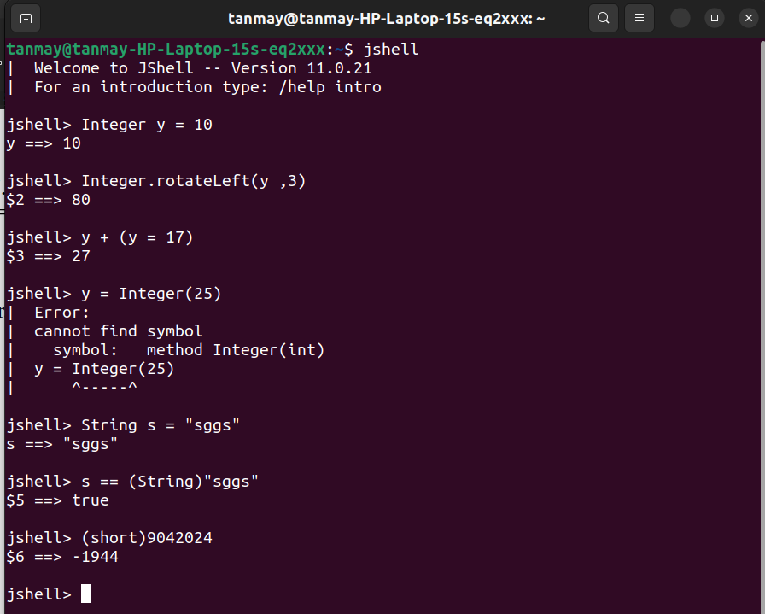

Que 2
a.
soln. This error occurs when JVM fails to find or load main class while executing the program.

b.
soln> This error means that String literal is not closed using ” .
e.g.
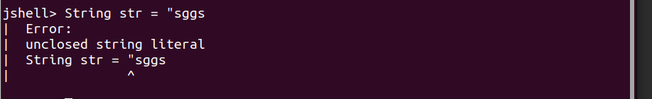

c.
soln> This error means that we are performing array operations on string.
e.g.
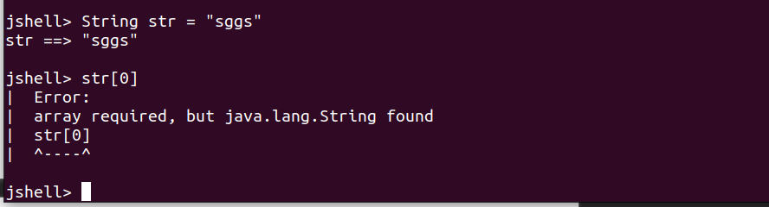

Que 4.
a.
Soln> It will show error, as constructor is being recursively call.
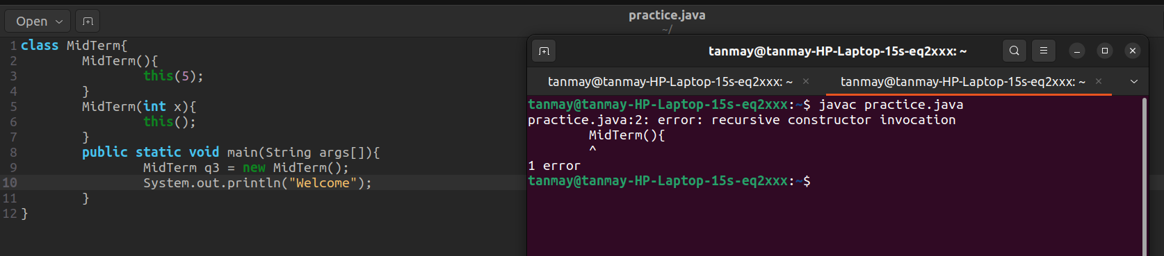

b.
Soln> Output: Examination: Mid
Since strings are immutable , if we are concatenating Semester with it we again have to store it in exam.

c.
Soln> It will show stack overflow error.

d.
Soln> Output:
Static Block 1: EXAM
Static Block 2: EXAM
Static Block 1: MIDTERM
Static Block 2: MIDTERM
Welcome to Mid Term Examination
Init Block: EXAM
EXAM Constructor
Init Block: EXAM
EXAM Constructor
Init Block: MIDTERM
MIDTERM Constructor
MidTerm

1) all the static block will get execute
2) then we will come to main method and welcome to mid term exmaination will get print.
3) Now we are making object of EXAM so its init block will get execute first, then its constructor.
4)Then wee arec making object of MidTerm since it extends EXAM so first init block of Exam and its Constructor will get execute then init block of MidTerm ans its constructor will get excute.
5)Since we are printing javaprogramming explicitly MidTerm will get print.

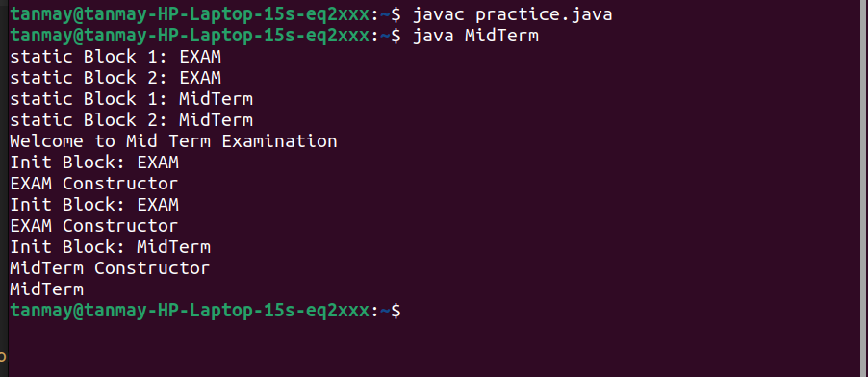

Que 5.
soln> 3 Object will get created
for str2 and str5 to new Object will get created as they made using new keyword.
Since str1 and str3 have same String Literal so both will have same address and once 1 object will get created.
Also str4 is also having address of str2 so it will use same object.

